**Become An Expert: Backend Projects That Define Senior Developers**

[[](https://pinjarirehan.medium.com/?source=post_page-----61ac76e17d98--------------------------------)](https://pinjarirehan.medium.com/?source=post_page-----61ac76e17d98--------------------------------)

[[Dev Genius](https://blog.devgenius.io/?source=post_page-----61ac76e17d98--------------------------------)](https://blog.devgenius.io/?source=post_page-----61ac76e17d98--------------------------------)

[P. Rehan](https://pinjarirehan.medium.com/?source=post_page-----61ac76e17d98--------------------------------)

·

Follow

Published in

[Dev Genius](https://blog.devgenius.io/?source=post_page-----61ac76e17d98--------------------------------)

·

6 min read

·

Jul 27

2.1K

12



Moving from being a mid-level developer to a senior-level developer is like leveling up in a video game.

You need to gather more experience points and unlock new abilities to conquer the challenges that lie ahead.

In the world of backend development, it means diving into the realm of sophisticated systems and becoming a coding wizard behind the scenes.

So, grab your magic wand, and let’s explore some exciting project ideas that will help you level up your backend programming skills and embark on the path to becoming a senior-level developer.

**RESTful API with Authentication & authorization**

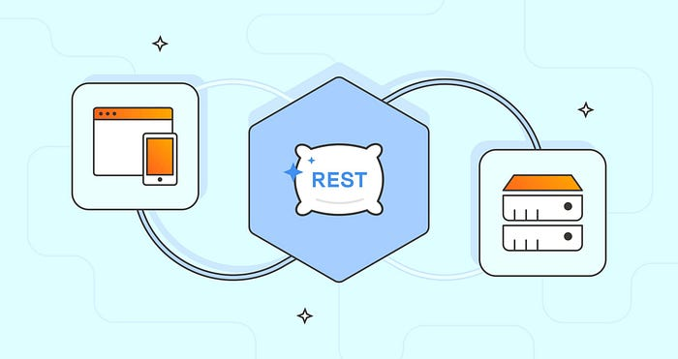

RESTful API

Imagine yourself as the mastermind behind a secret society of backend developers.

Your mission, should you choose to accept it, is to create a RESTful API with authentication and authorization.

You’ll wield frameworks like Express or Django to build an API that’s as secure as Fort Knox.

No unauthorized access is allowed! You’ll be the gatekeeper of the server-side logic, granting access only to those who prove themselves worthy.

**Task Scheduling & Background Jobs using a Job Queue**



Task Scheduling

But wait, there’s more! As a backend superhero, you’ll also need to master the art of task scheduling and background jobs.

It’s like juggling flaming swords while riding a unicycle — challenging yet exhilarating!

You can create a task scheduling system using a job queue like Bull or RabbitMQ, allowing you to execute asynchronous tasks and process background jobs like a pro.

Watch out, Cirque du Soleil, there’s a new performer in town!

**Real-time Chat Application using WebSockets**

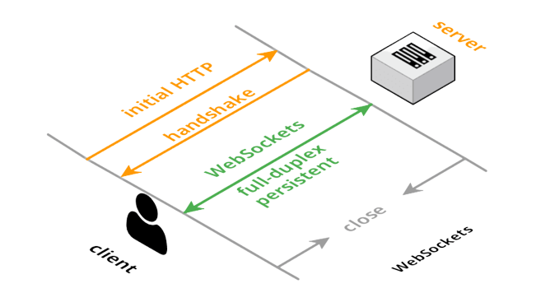

WebSockets

If you’re up for a real-time challenge, picture yourself building a chat application using WebSockets.

With frameworks like Socket.io or Django Channels in your arsenal, you’ll be able to create a chat app that connects users in the blink of an eye.

It’s like hosting a conversation between superheroes, where messages fly at the speed of light.

Just make sure you have your spandex suit ready!

**Microservices Architecture with Communication Protocols**



Microservices Structure

Now, let’s take a journey into the world of microservices architecture.

It’s like building a city with interconnected buildings, each serving a specific purpose.

You’ll harness technologies like Docker and Kubernetes to create a microservices architecture that will make Tony Stark jealous.

Then, you’ll connect these services through REST APIs or message brokers, ensuring smooth communication between your digital metropolis’s inhabitants.

**Distributed Systems that are Scalable & Fault-Tolerant**

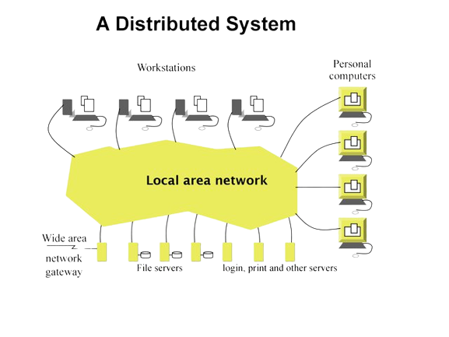

A Distributed Systems

But what about handling massive amounts of traffic? Fear not, for you shall conquer the realm of distributed systems.

Armed with the power of Apache Kafka, Apache Cassandra, or Redis, you’ll create a distributed system that can withstand the onslaught of millions of users.

It’s like managing a never-ending traffic jam, but instead of honking horns, you’re orchestrating data flow.

Gridlock has met its match!

**Putting Together a Content Delivery Network (CDN)**

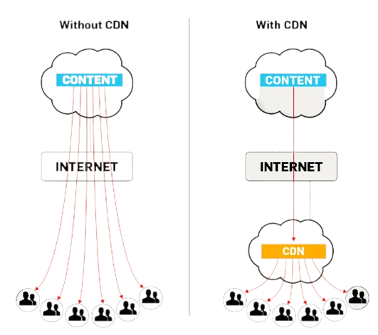

With & Without CDN

In your quest to optimize web application performance, you’ll become a master of content delivery networks (CDNs).

Think of yourself as a courier, delivering static content at lightning speed.

Using technologies like Nginx or Varnish Cache, you’ll create a CDN that can transport files faster than Flash.

Say goodbye to sluggish websites and hello to instant gratification!

**Implementing a Caching Layer to Improve Performance**

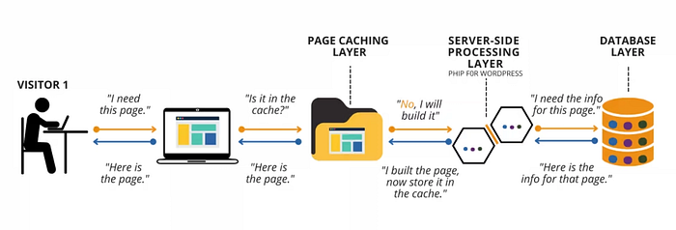

Caching Layer

To further enhance performance, you’ll integrate caching technologies into your backend system.

Redis or Memcached will become your trusty sidekicks, caching frequently requested data and unleashing the power of instant retrieval.

It’s like having a pocket dimension where information magically appears whenever you need it.

Your backend system will be as fast as a cheetah on roller skates!

**Creating & Improving Relational Database Schemas**



Database Schemas

As a senior-level developer, you’ll also be a master of databases.

You’ll create intricate database schemas optimized for efficient data retrieval and storage.

You’ll optimize queries, fine-tune relationships, and create indexing algorithms that would make Sherlock Holmes proud.

Your domain will be a labyrinth of organized data, ready to be explored by those who dare to venture into its depths.

**Creating a Data Processing & Web Scraping Service**

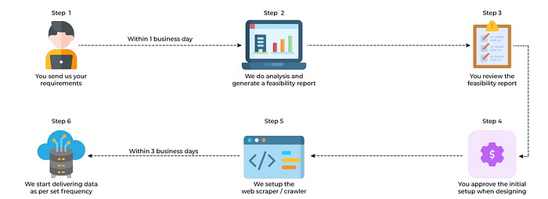

Web Scraping

But let’s not forget the thrill of data exploration.

You’ll become a data magician, creating a service that collects and processes data from the vast realms of the internet.

Using technologies like Scrapy or Puppeteer, you’ll scrape data from online sources and store it in a structured and orderly fashion.

It’s like hunting for buried treasure in the digital sea, with each piece of data a precious gem waiting to be discovered.

**Creating a Data Visualisation Analytics Dashboard**



Data Visualisation

Last but not least, you’ll create a data visualization analytics dashboard.

You’ll combine the power of frameworks like React or Angular with data visualization tools like D3.js or Chart.js to create stunning visual representations of complex data.

It’s like being an artist who paints with data, transforming boring numbers into captivating works of art.

You’ll be the Picasso of backend development!

**Final Words**

These backend projects will propel you toward a senior-level development career like a rocket-powered unicorn.

They will showcase your expertise in backend development, scalability, security, and performance optimization.

By taking on these projects, you’ll sharpen your skills, gain invaluable experience, and prove that you have what it takes to design and execute robust backend systems.

So, grab your cape, choose a project that sparks your interest, and embark on the exhilarating road to becoming a senior-level backend engineer.

If you found this article useful, don’t just stand there like a frozen statue — give it a round of applause!

And if you have any thoughts or opinions, feel free to share them. I love hearing from fellow backend superheroes.

Thank you for joining us on this epic backend adventure!

Until next time, happy coding and may your servers never crash!

Parting is sweet sorrow, but a $1 coffee would make it sweeter!

[[](https://www.buymeacoffee.com/prehan)](https://www.buymeacoffee.com/prehan)

Click 👆 to support!

**👋 Need Web Development Help?**

I’m your go-to web developer, and I’m flexible to meet your needs. Whether you’re looking for a remote team member or a freelance expert, I’ve got you covered.

**My Expertise:** I specialize in:

* 💡 ReactJS
* 🎨 UI/UX Designer
* 🚀 Backend development
* 🌐 APIs
* 🚀 Node.js
* 🎨 Responsive designs
* 🏗️ Building websites from scratch
* 📊 Database management
* ✨ Figma design

**Let’s Work Together:** Whether it’s a small task or a big project, I’m dedicated to delivering results.

🤝 **Ready to Start?** Reach out to me at [***prehandev@gmail.com***](mailto:prehandev@gmail.com) or find me on ***[Linkedin](https://www.linkedin.com/in/pinjari-rehan/" \t "_blank)*** or [***Upwork***](https://www.upwork.com/freelancers/~01340235d62d5f3c0d).

Thank you for considering me, Looking forward to working together!

Warm regards,

**P. Rehan.**